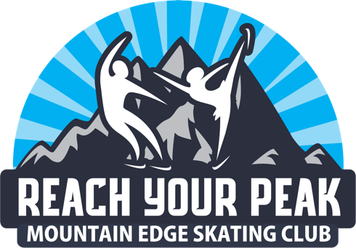 Competitor’s Fund
Mountain Edge Skating Club wants to support our competitors as they showcase their talents around the country. MESC has determined competitor’s funding levels for the competitive year (2023-2023). This funding is available to all home club full members who renewed their memberships by June 30, 2022. The Fund Application should be emailed to the MESC treasurer at treasurer@mountainedgesc.org. Introductory members are not eligible for any funding. Funding requests must be submitted by December 31, 2022. Adjustments to funding requests can be made as needed. Skaters may only apply for one event per membership year.
Funding will cover COACH FEES ONLY and will be paid directly to the coach upon receipt of the coach’s itemized invoice. The invoice should be given or emailed to the MESC treasurer at treasurer@mountainedgesc.org.
• Championship Series and Excel Series:
o Regionals at qualifying level (Intermediate through Senior) coaching fees up to $200
o Excel Nationals at qualifying level (Intermediate through Senior) coaching fees up to $200
• Synchro Team Members:
o Individuals skating on a Synchro team:
 Sectionals: coaching fees up to $100 per competitor (Intermediate level or above)
 Nationals: coaching fees up to $200 per competitor (Intermediate level or above)
• National Showcase:
- Individuals skating: coaching fees up to $200 (Intermediate - senior & collegiate level)
• Sectional Pairs, Dance and Singles Competitors:
o Coaching fees up to $200
• National Pairs, Dance and Singles Competitors, National High Performance Development Camp (Junior & Senior level):
- Coaching fees up to $400

Competitors receiving funding have agreed to represent Mountain Edge Skating Club on the ice and through their behavior throughout the event. Our skaters should be positive role models and display good sportsmanship when at an event. Competitors should wear MESC apparel when possible.

Best wishes to all MESC competitors,
Mountain Edge Skating Club Board

Updated 7/22

